1. **LOGIN MENU**

**Link :** [**https://www.figma.com/file/K1oFnytBAaXPhoBjP0CTM6/Login-Form-Techno-Cashier?node-id=0%3A1&t=jDjzoOQ1dv2AgRvI-1**](https://www.figma.com/file/K1oFnytBAaXPhoBjP0CTM6/Login-Form-Techno-Cashier?node-id=0%3A1&t=jDjzoOQ1dv2AgRvI-1)

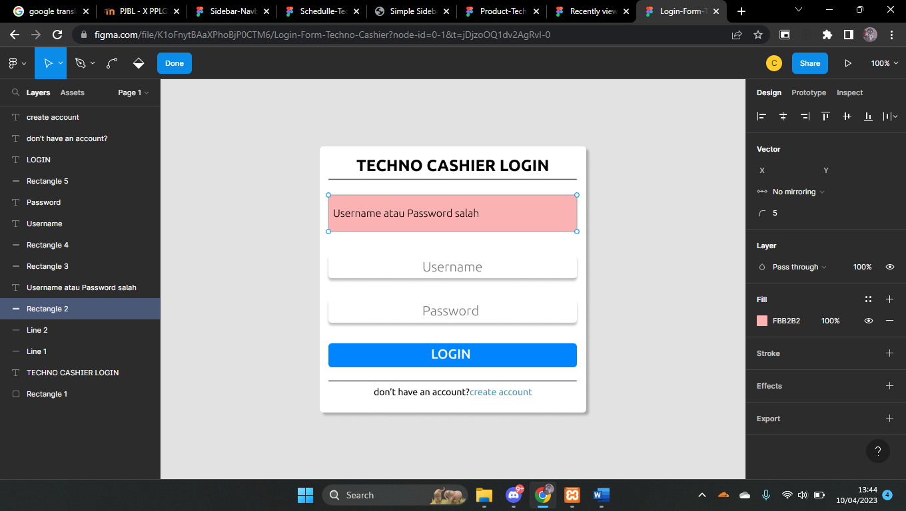

1. **Dashboard**

**Link :** [**https://www.figma.com/file/eEbfj5dHaL5rGDlf0zf7pO/Dashboard-Techno-Cashier?node-id=0%3A1&t=kpI5yVaqAR5qFFEi-1**](https://www.figma.com/file/eEbfj5dHaL5rGDlf0zf7pO/Dashboard-Techno-Cashier?node-id=0%3A1&t=kpI5yVaqAR5qFFEi-1)

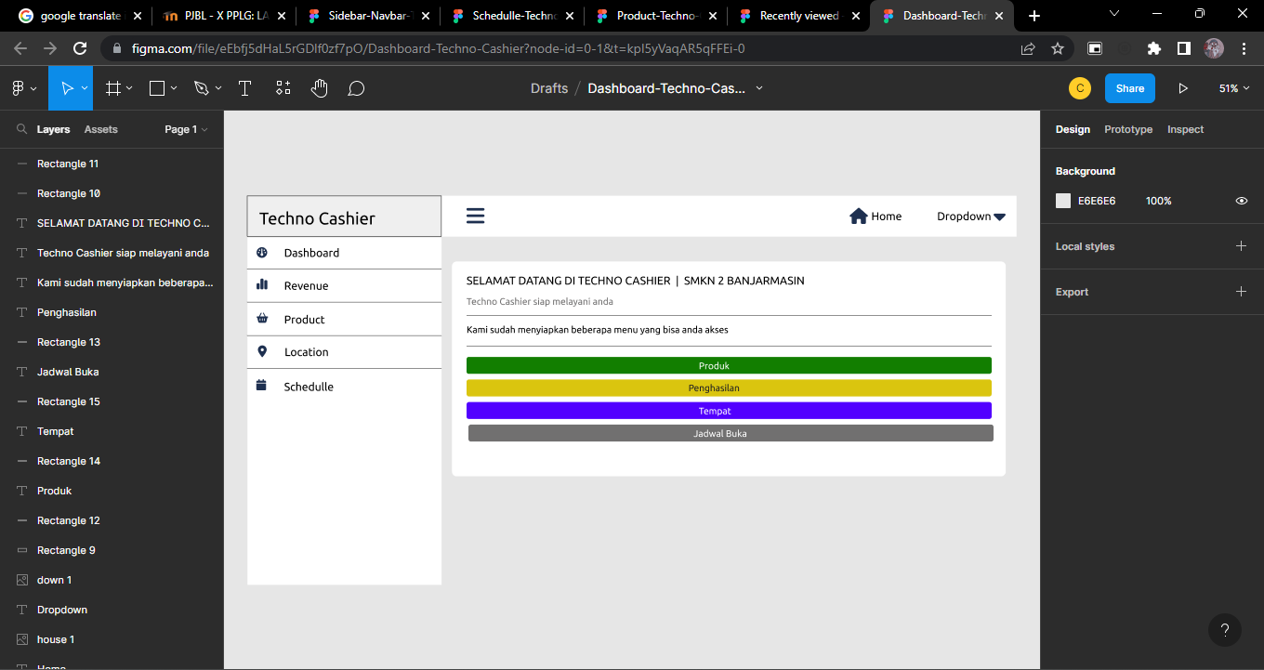

1. **Product menu**

**Link :** [**https://www.figma.com/file/DNfYTrBlVK7zWsgNfqhZSm/Product-Techno-Cashier?node-id=0%3A1&t=vY0qVjrGaKWpYlhv-1**](https://www.figma.com/file/DNfYTrBlVK7zWsgNfqhZSm/Product-Techno-Cashier?node-id=0%3A1&t=vY0qVjrGaKWpYlhv-1)

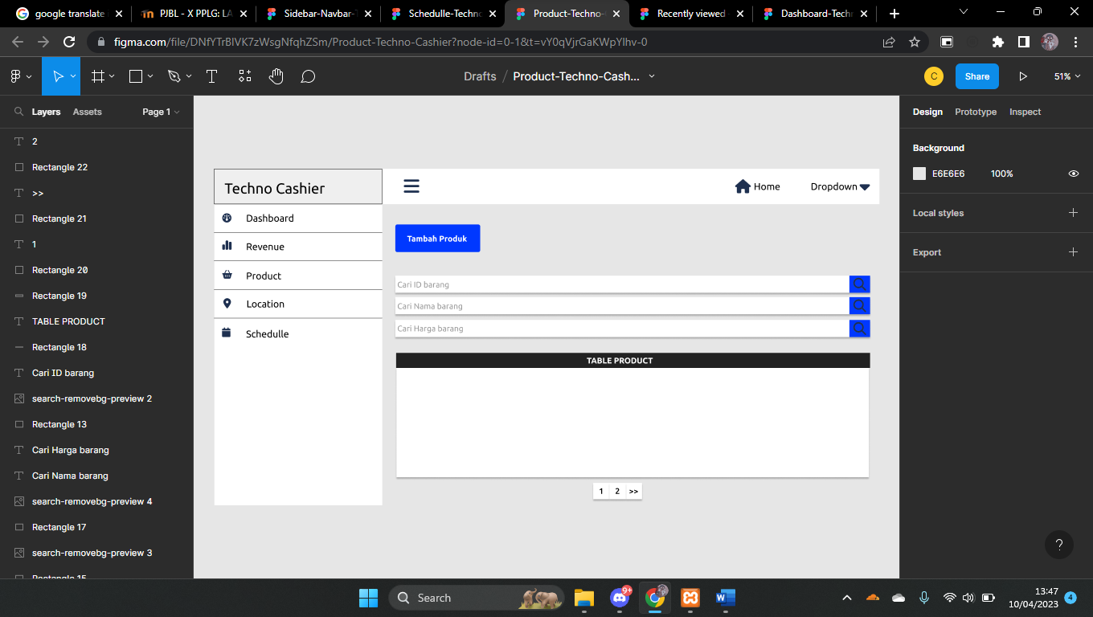

1. **Revenue Menu**

**Link :** [**https://www.figma.com/file/qjLVfDmTDHTtrKS2AKX6ms/Revenue-Techno-Cashier?node-id=0%3A1&t=w5CFe2kLAMAeChqS-1**](https://www.figma.com/file/qjLVfDmTDHTtrKS2AKX6ms/Revenue-Techno-Cashier?node-id=0%3A1&t=w5CFe2kLAMAeChqS-1)

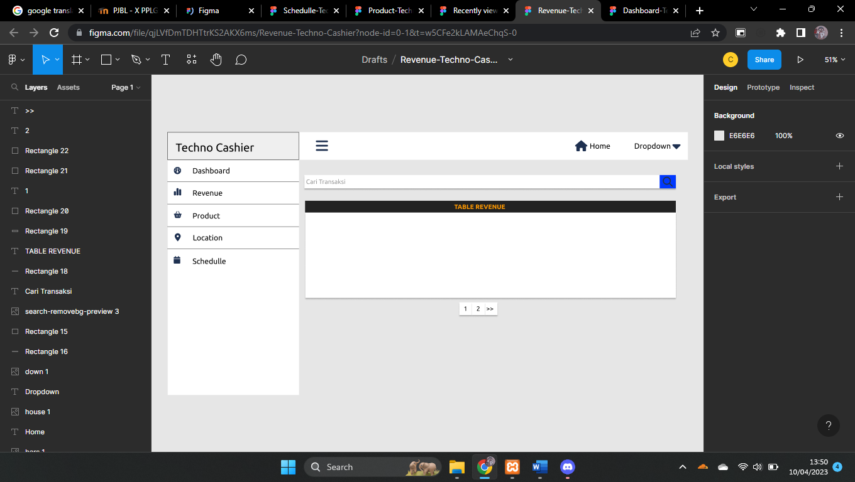

1. **Schedule**

**Link :** [**https://www.figma.com/file/fsJdetMM7WnBq0JuRGUSXb/Schedulle-Techno-Cashier?t=8AoP0hppgMiiaIRs-1**](https://www.figma.com/file/fsJdetMM7WnBq0JuRGUSXb/Schedulle-Techno-Cashier?t=8AoP0hppgMiiaIRs-1)

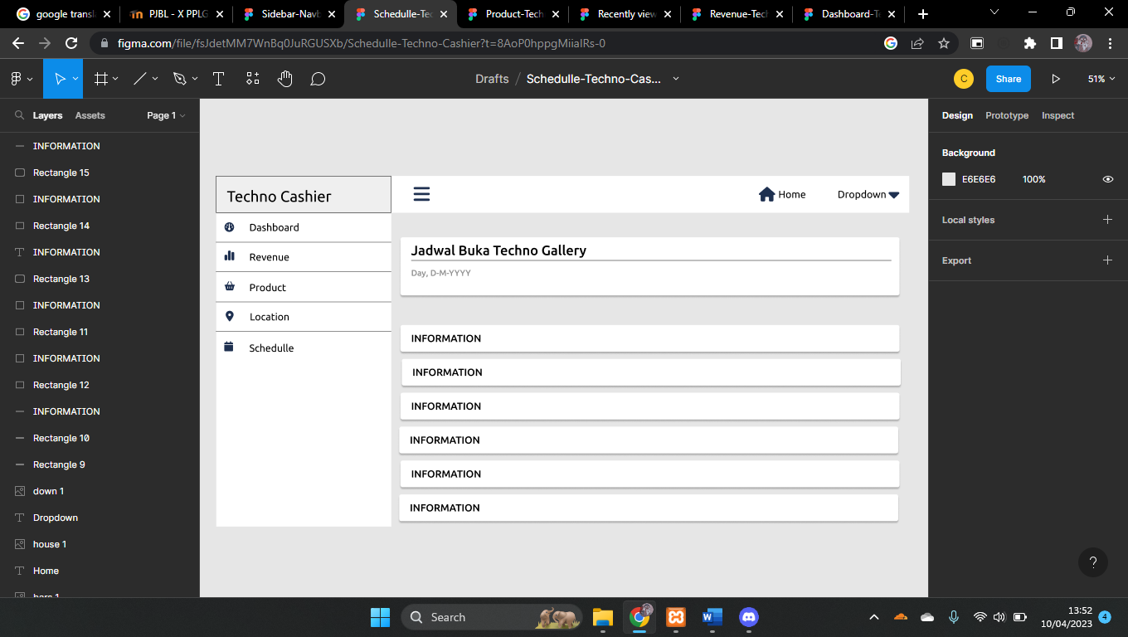

1. **Sidebar & Navbar**

**Link :** [**https://www.figma.com/file/kB2o41m8BBDuI7eHCCBWNT/Sidebar-Navbar-Techno-Cashier?node-id=0%3A1&t=kJQU3Q8H4mZxAmDA-1**](https://www.figma.com/file/kB2o41m8BBDuI7eHCCBWNT/Sidebar-Navbar-Techno-Cashier?node-id=0%3A1&t=kJQU3Q8H4mZxAmDA-1)

